COMP231-S62G1

Group 1

Food order app – User guide for Vendors

Table of Contents

Purpose 2

Identifying Users 3

Viewing the Vendor Site 3

Vendor Operator 3

Login 3

Vendor Manager Access Options 3

Viewing Orders 4

Managing Orders 4

Viewing Order Detail 6

Sending Updates 7

# Purpose

The main purpose of this guide is to allow vendors to manage the orders that come through the user side of the food order application.

The core functionality of the application is as follows:

1. Identifying users: Logging in to the application
2. Viewing orders: Users are able to view orders from customers
3. Managing orders: Functionality for a user to accept an order
4. Sending Updates: Status updates and confirmation that the order is/has been processed

# Identifying Users

# Viewing the Vendor Site

Vendor staff are able to access the webpage version of this application to manage and view orders that are registered into the system.

### Vendor Operator

1. Launch the webpage.
2. Login – select type, enter username and password.
3. Depending on the user type, a page is displayed. For example, for a Vendor Operator, the Order List page is displayed.

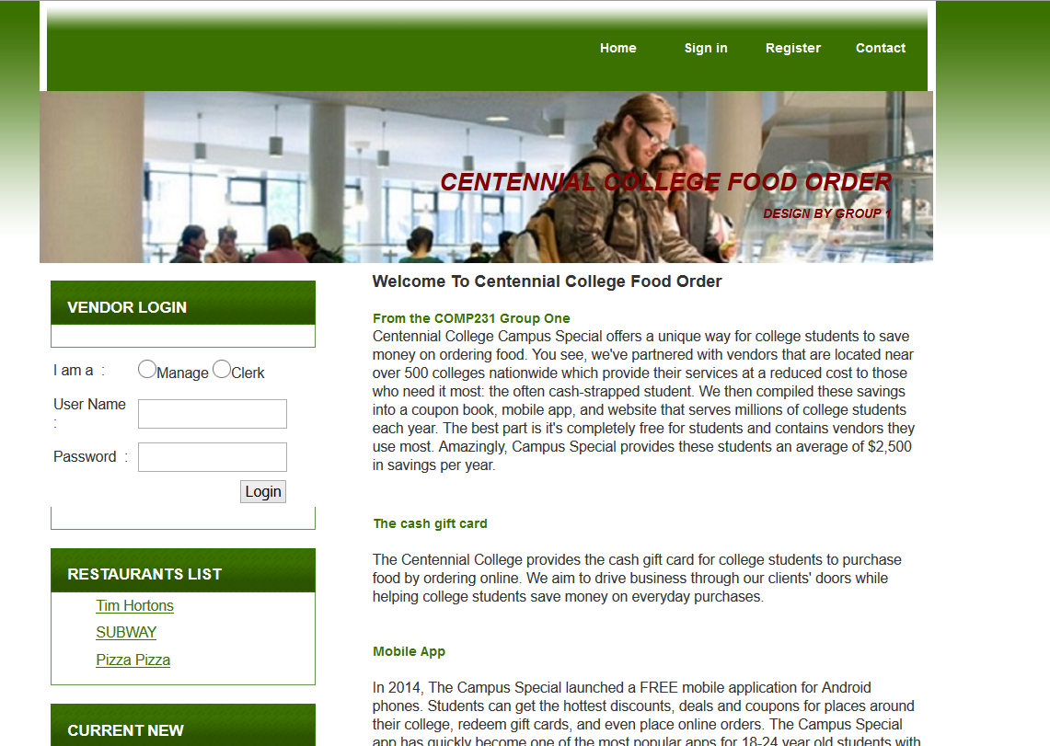

### Login

TBD

### Vendor Manager Access Options

TBD

# Viewing Orders

# Managing Orders

Vender user will have an ability to manage orders. Once new order was registered on the system, vender user can confirm or reject the order. Once order is confirmed, vender will process the order and when the ordered food are ready, vender user can check the order as completed and system can send a notification message to ordered customer.

Confirm orders

Vender user can confirm new order on order detail screen by clicking Confirm the order button. Once vender user confirms the order, order status in the server is updated to Under the processing.

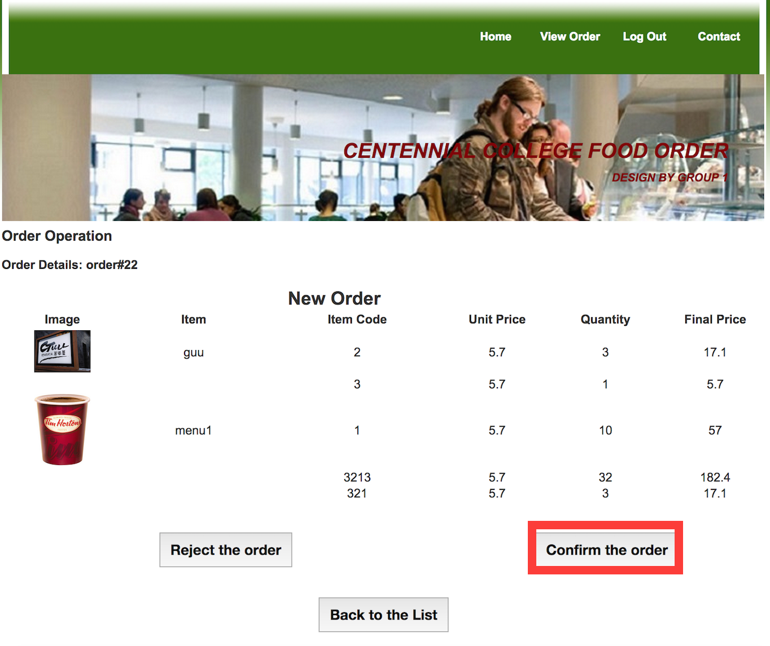

Figure Order confirmation

Reject orders

Vendor user can reject new order on order detail screen by clicking Reject the order button. Once vender user rejects the order, order status in the server is updated to ‘Rejected’.

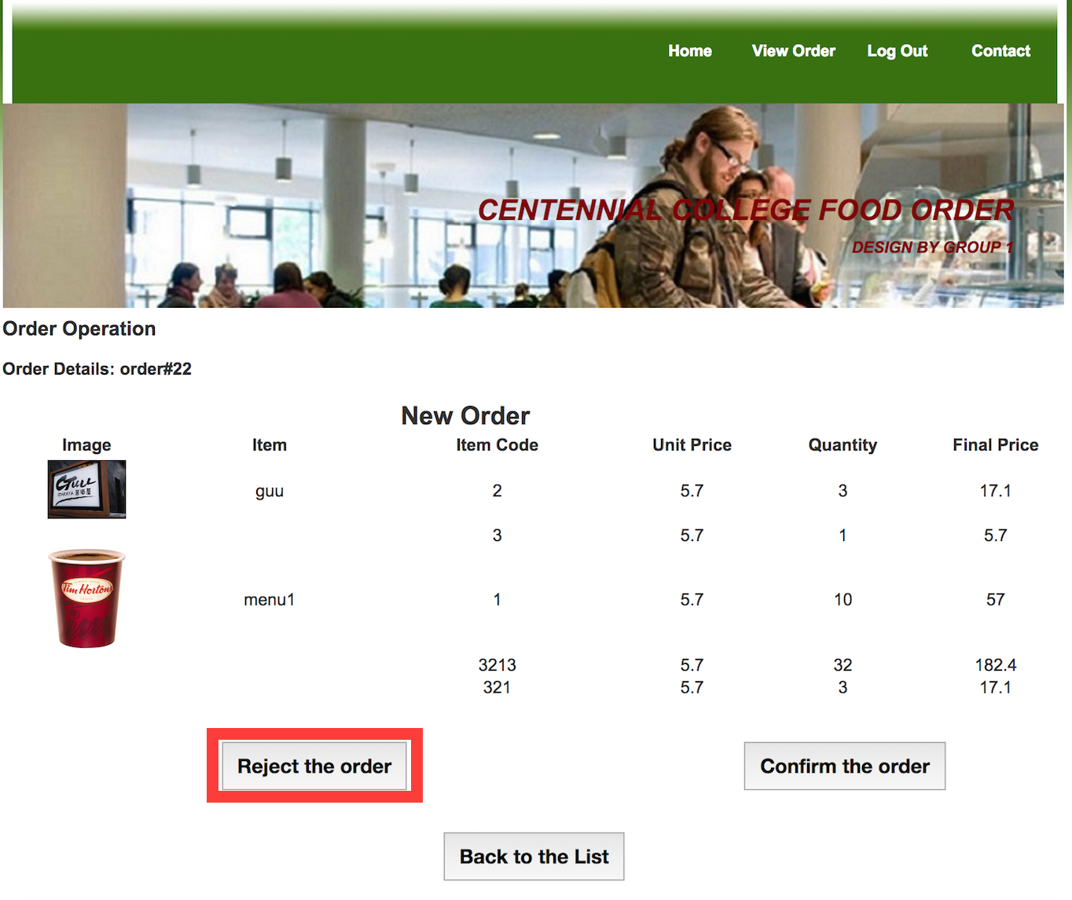

Figure Order Rejection

# Viewing Order Detail

The order detail page will allow a restaurant operator to view the details of the order he/she has selected from the order page.

1. Select the order by double-clicking the item to be selected in the table.

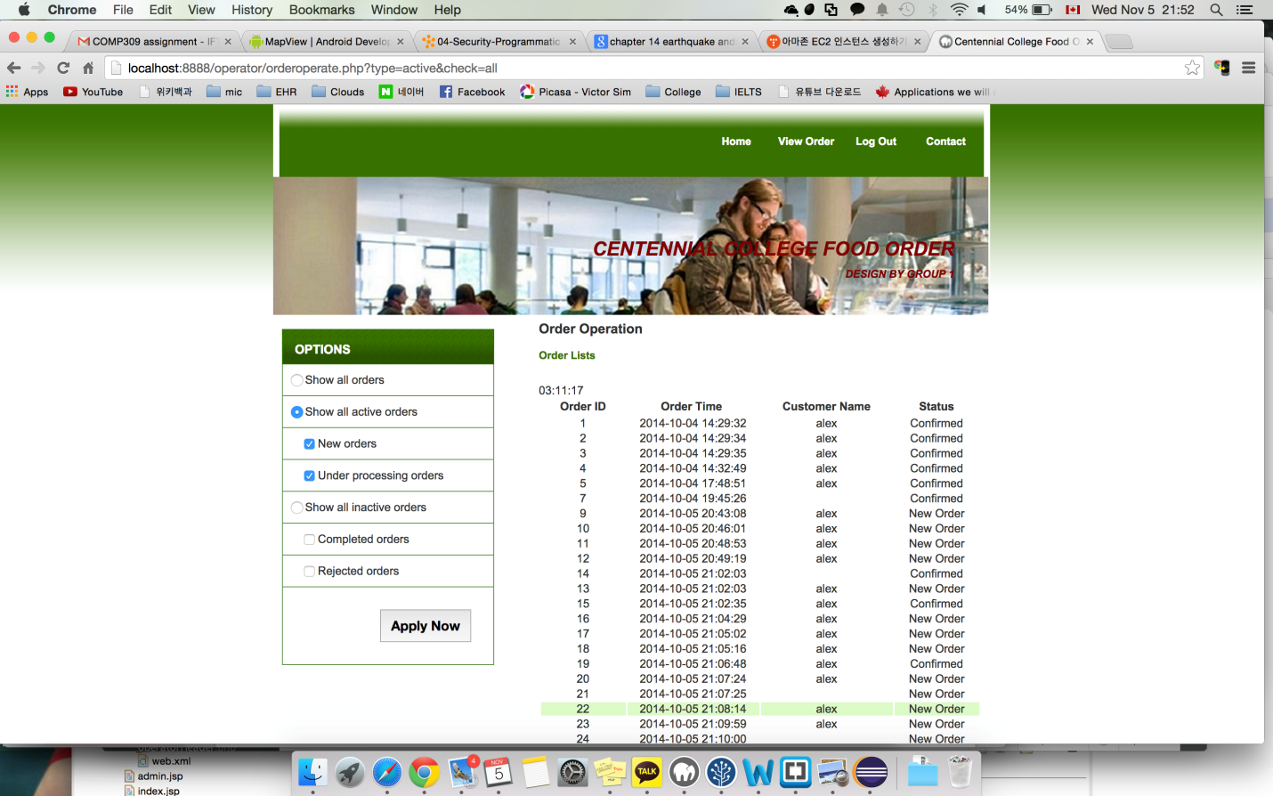

Image 1: Order Page

1. The order detail page is launched:

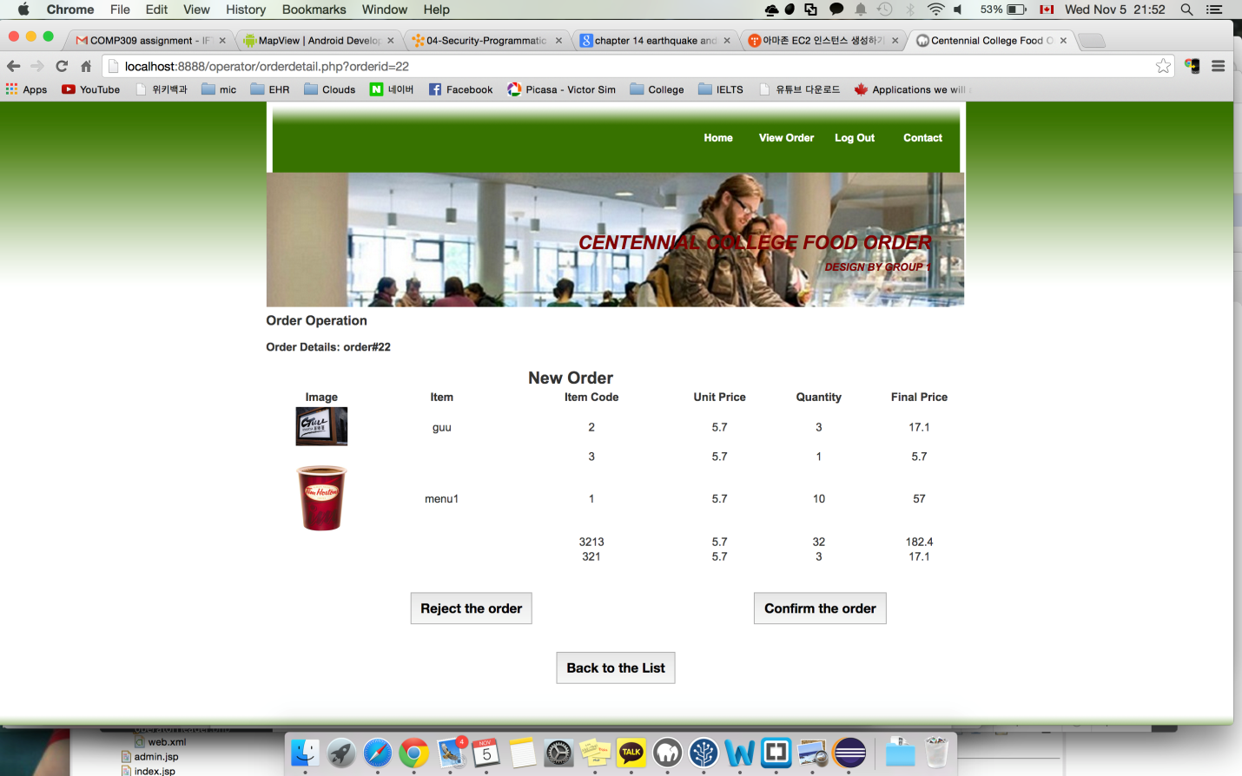

Image 2: Order Details View Page

1. Review the detail of order. The following options are available:
   * The items of the selected order are available: click the “Confirm the Order” button. The order page will be launched and the status of the order will be updated as “Confirmed”.
   * The items of the selected order are not available: click “Reject the Order” button. The order page will be launched and the status of the order will be updated as “Rejected”.
   * The status of orders is displayed: Click the “Back to the List” button. The order page will be launched and the current status is displayed under the “Status” column of the list of orders.

# Sending Updates

Clerks can send updates to the consumer containing the status of their order.

1. Clerk selects one of the following: Confirm or Reject.

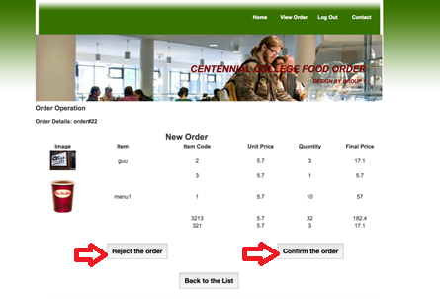

1. If “Confirmed”, the following page is displayed:

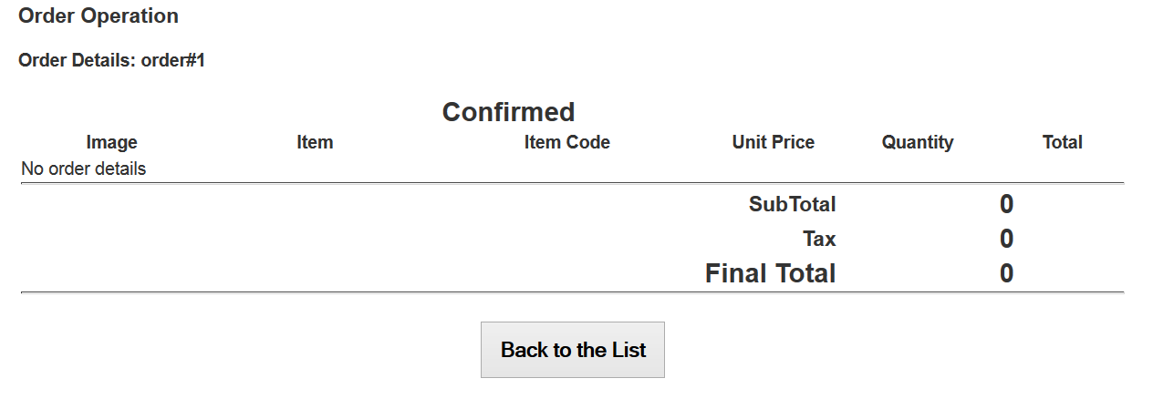

1. If “Rejected”, the following page is displayed:

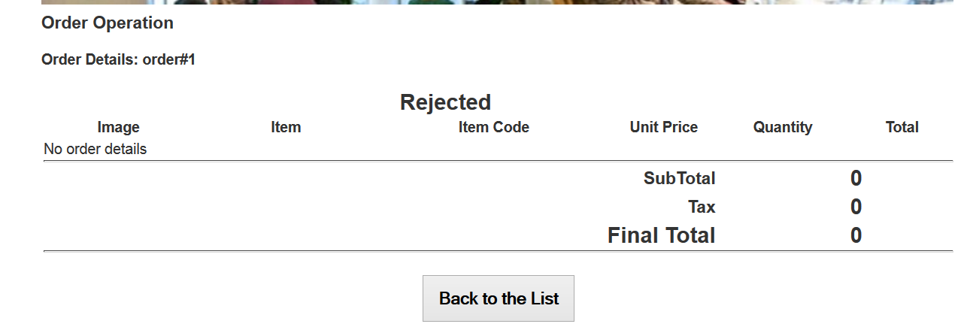

1. The consumer will receive a notification and can check the status update on their mobile application.